

Deliverable 3

IS 623 Prof. Isaac Vaghefi

December 16, 2019

**ClassHook**

Group #3

Jibin Thomas

Matthew Esposito

Jaymeen Gandhi

Sweni Thakkar

Table of Contents

History and Company Overview2

Functionality2

Business Details3

Hierarchy Details4

Process Functionality3

**System Workflow Diagram4**

**System Request5**

**Feasibility Assessment6**

Technological Feasibility6

Economical Feasibility7

Cost Benefit Analysis8

Organizational Feasibility9

**Project Work Plan10**

Planning Phase10

Analysis Phase10

Design Phase11

Implementation Phase11

**Risk Assessment12**

**Requirement Definition13**

Functional requirements**13**

Nonfunctional requirements**13**

**Interviews15**

Summary Report**15**

Survey**16**

**Use Cases20**

**DFDs24**

**ER Diagram30**

**Alternative matrix 31**

**Refined nonfunctional requirements 33**

**System specification: 34**

Interface design 34

Web page/main menu/main page layout 35

System's Interface Structure Diagram or Dialogue Diagram 36

Site Map 37

Interface standards 38

File/data specification 39

Physical data model and report the revised CRUD matrix 40

**Executive Summary42**

**Project Lessons Learned43**

**References44**

## History and Company Overview

Alex Deeb, CEO of ClassHook and Joyce Ang, Co-Founder of ClassHook established the company in 2007. ClassHook is an ed-tech company located in California that helps teachers use tv series and movie clips in their lessons to increase student engagement. Technology is constantly evolving in today’s fast-paced society. Today's students are growing up in the digital age where they don't know a world without smartphones, tablets, and wireless internet. As a result, traditional teaching methods need to adapt to their interests. The primary goal of ClassHook is to provide teachers an online portal where they can easily discover curated popular media clips with educational content and inspire students to position them for success. Bringing television shows and movies to the classroom through ClassHook help students' connect their personal lives to the concepts that are covered in class. As a result, content retention increases, and learning becomes more fun.

## Functionality

ClassHook provides teachers the tools to connect with students. The current system allows teachers to view and display curated educational content to students in a meaningful way. However, the web portal is mainly oriented towards teachers with limited functionalities for students. From the teacher’s perspective, there is a need for an online portal to conduct courses, host classrooms, and perform all educational activities such as store class material, conduct tests and assignments, assign grades, post due dates and feedback, make announcements etc. Our project aims to address this issue by reorganizing the current interface and adding additional functionalities specifically for teachers.

The proposed system would allow a teacher to take the teaching experience to the next level by hosting a virtual classroom and conducting live courses through these classrooms. Students enrolled for such courses can communicate with the instructors through ClassBoard, a workspace with integrated learning tools which allows teachers to create and post live content to registered students.

Also, the current ClassHook system from a student’s perspective is limited. The proposed system would allow a student to view and enroll for courses, create media clip libraries, and share the created libraries with other users.

In conclusion, we expect that adding additional functionalities and features to ClassHook will result in a significant increase in user subscriptions. We have collaborated with the ClassHook team to better understand the feasibility of our project (supported by pages 6 – 9) and concluded that the project would be favorable to the company as it would revamp the current system with added functionalities to compete with other learning management systems in the market.

## Business Details

The organizational chart of ClassHook (as represented below) is a top down approach from Alex Deeb (CEO of ClassHook) who leads the highest priority strategic business initiatives to the lowest level employees whose main responsibilities include but are not limited to operational activities.

Hierarchy (levels at the company)

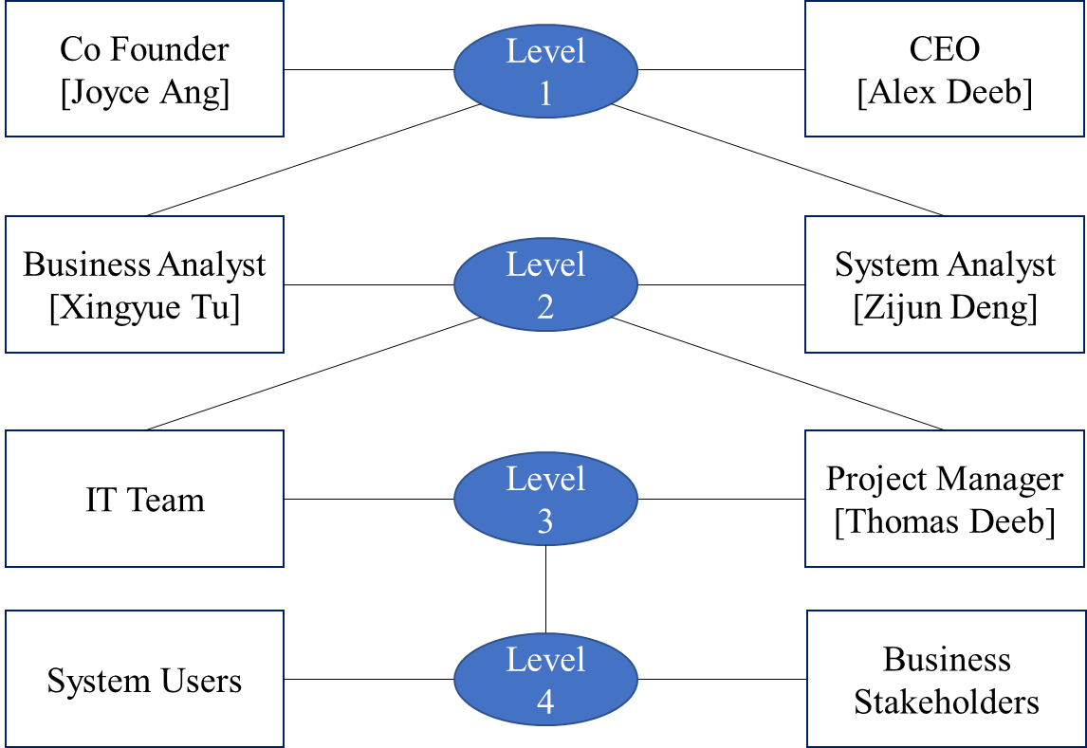

# System Work Flow Diagram

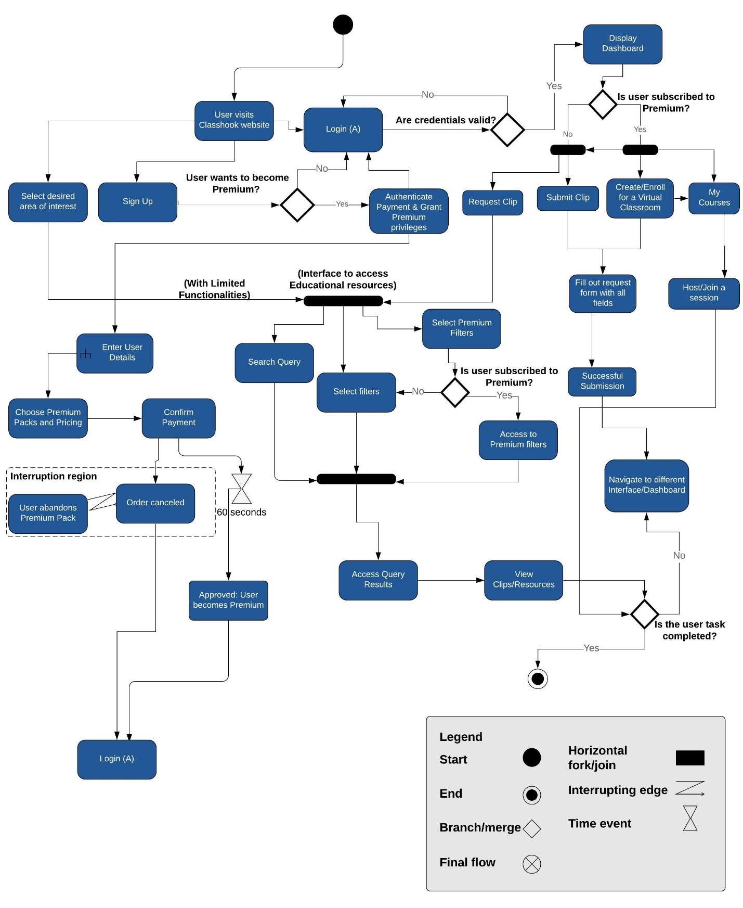

# System Request

|  |  |
| --- | --- |
| System Request | |
| Project Sponsor: | Alex Deeb, CEO, ClassHook |
| Business Need: | This project has been initiated to deploy useful functionalities and subsequently increase the number of subscriptions at ClassHook - an online learning portal. This project is introduced due to the rise of the following needs:   * The current system has limited functionalities for students. * There is a need for an online portal to conduct courses, host classrooms, and perform educational activities such as store class material, conduct tests and assignments, assign grades, post due dates and feedback, make announcements etc. * Define new methods to increase and organize the media files in the current system. |
| Business Requirement: | * Create separate dashboards for teachers and students with specific set of functionalities. * Develop new functionalities which would enable a teacher to create and host a virtual classroom and integrate it with the current existing system. * Users can set up and customize libraries consisting of educational media clips and share content with other users. |
| Business Value: | * With new and improved functionalities, the number of users and subscriptions is expected to significantly increase at least by 55% with a ROI of 2,628%. * Intangible aspects such as increased customer engagement, user satisfaction, and brand recognition, will be increased. |
| Special Issues/Constraints | * The project needs to be completed within 3 months. * Copyright issues for the educational media content needs to be addressed. |

Feasibility Assessment

**Feasibility Report:**

The proposed system for ClassHook was analyzed and the feasibility study was conducted for the technological, economical and organizational aspects. Following are the highlights from the feasibility report conducted for the newly proposed system:

## Technological Feasibility

**(Can we build it?)**

|  |
| --- |
| * The proposed ClassHook system is technically feasible with a very low risk factor as the system is primarily based on web applications which the users are very familiar and experienced with. Also, the proposed system being an extension of the current system in the same domain and platform, the IT team and working staff are well equipped and familiar with the required databases and the web-based technologies used to deploy the system. Thus, ***ClassHook’s risk regarding familiarity with technologies is relatively low*** * The project size is moderate with a group of 4 members working together the defined strategic goals for the project. ***The project size is a moderate risk*** * The proposed system is compatible with the current system and technical infrastructure. Newly defined functionalities need to be integrated to the current system and its technologies. The new system will be able to support the new functionalities and serve more users with better data traffic handling. ***The compatibility risk is low*** * The time frame for the proposed system is critical as the system needs to be deployed within 3 months. The system would be analyzed and subjected to revisions at various phases. With adequate planning and management, ***the new proposed system is achievable and can be completed as per the schedule and estimated deadline using the IT infrastructure and resources.*** |

|  |  |  |
| --- | --- | --- |
| **Economic Feasibility: Should We Build It?** | | |
| **Factors** | • Development costs | • Annual operating costs |
| • Annual benefits (cost savings and/or increased revenues) | • Intangible benefits and costs |
| To assess the economic feasibility, it is important to analyze the costs and benefits associated with the proposed project. After determining the costs and benefits of the new system, our group will analyze the project using Net Present Value (NPV), Break Even Analysis, and Return on Investment (ROI). We evaluated the increased educator satisfaction, development costs, and operations costs over the next four years. Our Cost Benefit Analysis resulted in an approximately one year where the company would break even from our project, 2,628% return on investment and a positive NPV of $105,022.78. We collaborated with the ClassHook team to better understand the economic feasibility of our project and concluded that the project would be favorable to the company relative to the expenditure of resources needed to complete it. | | |

## Economic Feasibility

# Cost Benefit Analysis



Organizational Feasibility

|  |
| --- |
| **Project Strategic Alignment** |
| From ClassHook’s organizational perspective, the proposed system carries low risk. Alex Deeb (the project champion) and Joyce Ang have a strong interest with our IS623 project. Their extensive experience and valuable insights would help us achieve the defined strategic goals.  The proposed system adds value to the existing system as teachers and student users would benefit from the newly defined functionalities. |
| Developing the proposed system aligns well with ClassHook’s strategic goals. The system will enable teachers to create virtual classrooms and educate students in a meaningful way. The virtual classroom will also allow the teacher to perform educational activities including but not limited to store class materials, conduct tests and assignments, assign grades, post due dates and feedback, make announcements etc. Registered students can join virtual classrooms created and hosted by teachers. The students can submit their assignments through the virtual classroom which in turn will be reviewed and graded by the professor. In addition, the proposed system will allow users to create customized libraries which can be shared among other users. The proposed system will attract more users due to these virtual classrooms. The proposed ClassHook system will be gradually accepted by the users and will be incorporated to the existing system since it is being built on the extension of the previous platforms. We have a strong strategic alignment to the goal which will than relatively result into lesser riskier project. |
| **Project Champion: Alex Deeb** |
| The project champion Alex Deeb will serve as the sponsor of the project as well. The champion would make sure that the team is headed to the right way of completing the project. He would ensure that every milestone is being achieved in the proper time frame. He would resolve the issues if the team members get stuck to tackle an issue. |
| **Senior Management: Joyce Ang, Xingyue Tu, Zijun Deng** |
| The senior management would fully be coordinating with us about the project. They would help in advertising about the new functionalities in other websites. They would ensure that adequate funds are provided to the team to successfully accomplish the project. |
| **Users and Stakeholders** |
| In this case the users are the students or the users who are accessing ClassHook. They would use this new system and get impacted by it. They would provide with their valuable feedback about the system and tell us about our errors and changes which are required. Their feedback will be taken into consideration by the technical team and appropriate changes will be made. |

Project Work Plan

Planning phase

Planning phase involves creating set of plans to help guide the team through the execution and closure phases of the project. The plans created during this phase will help to manage time, cost, quality, change, risk and issues.

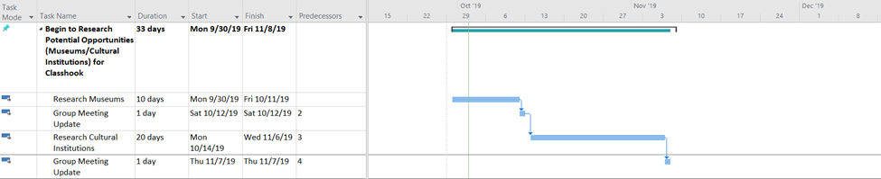

Analysis Phase

Analysis Phase categorize the overall direction that the project will take through the creation of the project and strategy documents. The main attraction of analysis phase is gathering requirements.

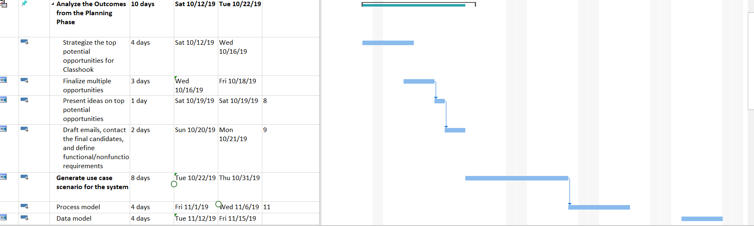

Design phase

Documents from the previous phases are revised in design phase. Interface is assembled for the system in this phase. Physical data models and CRUD matrix is prepared during this phase.

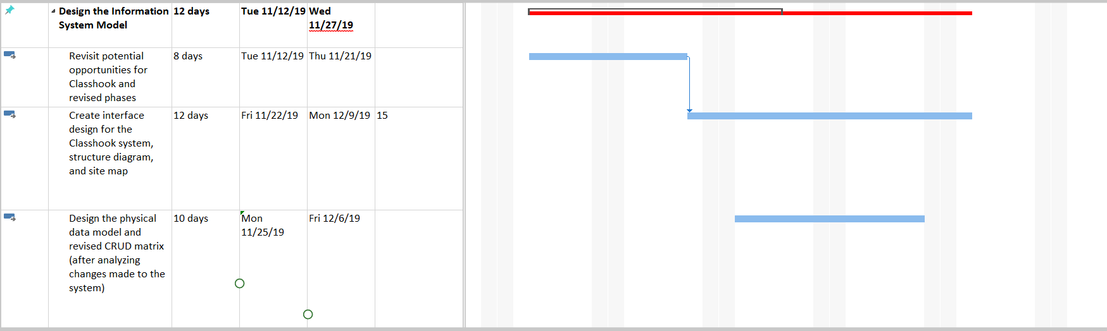

Implementation phase

The project plan is put into motion and the work of the project is performed. The system’s prototype is reviewed and deployed for the production.

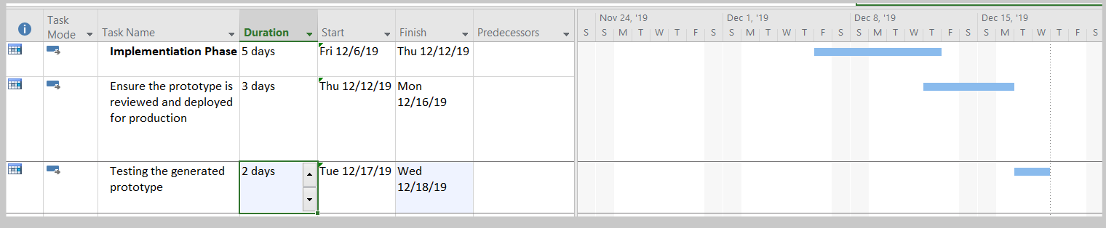

# Risk Assessment:

The proposed system for ClassHook was analyzed for potential risks which could affect the system and the following report was generated.

|  |  |
| --- | --- |
|  | |
| **Risk#1** | System crashes due to overload of concurrent users accessing the web portal. |
| *Likelihood* | Moderate |
| *How does it impact the system?* | A potential crash means the web portal is rendered useless with very limited functionalities. |
| *Solutions to address the risk?* | Maintain and update the system to make sure that it can hold more users than expected. |
|  |  |
| **Risk#2** | Serves goes down due to technical issues. |
| *Likelihood* | Low |
| *How does it impact the system?* | Users are not able to access the web portal. |
| *Solutions to address the risk?* | Deploy staff to carry out troubleshooting at regular intervals. |

# Requirements Definition

During the analysis phase of the SDLC, functional and nonfunctional requirements are prepared from the business’ perspective to better understand what the system is required to do and satisfy the user’s needs. The system functional requirements listed below provide additional details on the enhanced system functionalities created to support user needs. Furthermore, the nonfunctional requirements provide descriptions of a variety of system characteristics and what the final result of the system should be like upon completion.

**Functional Requirements -**

1. Process Oriented:

* The system will allow teachers to create a virtual classroom for students to provide an inclusive learning environment
* The system will allow students to participate in class discussions via group chat
* The system will allow students and teachers to browse videos by predefined categories
* The system will allow a user to create libraries with the desired videos, discussions, and comments
* The system will allow users to share each other’s libraries and post discussions and comments
* The system must allow registered teachers and students to review their purchase history for the past 5 years

1. Information Oriented:

* The system will allow users to view the active courses hosted by the teacher through virtual classrooms
* The system will allow users to view each other’s profile and libraries
* The system must retain the user’s username and password
* The system must maintain the user’s video history for one year

**Nonfunctional Requirements:**

1. Operational:

* The system should run on any technological device (Apple and Android mobile devices, tablet, laptop, desktop) used by employees, students, and teachers
* The system should be compatible with any web browser (Google Chrome, Internet Explorer, Microsoft Edge, Firefox, Safari, etc.)
* The video database will be constructed to facilitate searches by subject topic
* In the event of a failure during a virtual classroom or video download, the customer will be able to restart the download

1. Performance:

* The system should support up to 1,000 teachers and 30,000 students
* Download speeds for videos will be monitored and maintained at acceptable levels
* The user and system interaction should not exceed 1 second
* The system should be available to users for 365 day a week, 7 days a week, 24 hours a day

1. Security:

* Only teachers may host a virtual classroom for student collaborations and discussions
* Virtual classrooms are only available for subscribed teachers and are restricted to free users
* Only registered students may join a virtual classroom
* Only administrators have the authority to make website changes to ClassHook
* The system includes the necessary safeguards against viruses
* Personal information will be secured
* Payment information will be encrypted and secured

1. Cultural and Political:

* User’s personal information is protected in compliance with the United States Privacy Act of 1974
* The system should be able to distinguish between US currency and foreign currencies

**Interview Notes Approved by Group #3**

**Person Interviewed:** Alex Deeb, CEO of ClassHook

**Interviewer:** Matthew Esposito, Business Analyst

**Purpose of Interview:** Determine current system problems and create new functionalities to drive efficiencies and improve the current system

**Summary of Interview:**

*The largest problems with the highest priorities for current information system are:*

1. The current information system is a great way to enhance the student’s learning experience. However, the current web interface has limited functionalities.
2. The system is primarily oriented towards teachers which limits the amounts of users and their target audience. For example, adding additional features including but not limited to virtual classrooms and student dashboards would significantly expand ClassHook’s target audience and increase user subscriptions.
3. In addition to virtual classrooms and student dashboards, additional functionalities required include student libraries and the ability to share video clips between students.
4. Alex requires a streamlined process to scale vetted education content to enhance the company’s video database.

**Open Items:** N/A

**Detailed Notes:** See attached voice recording to support analysis



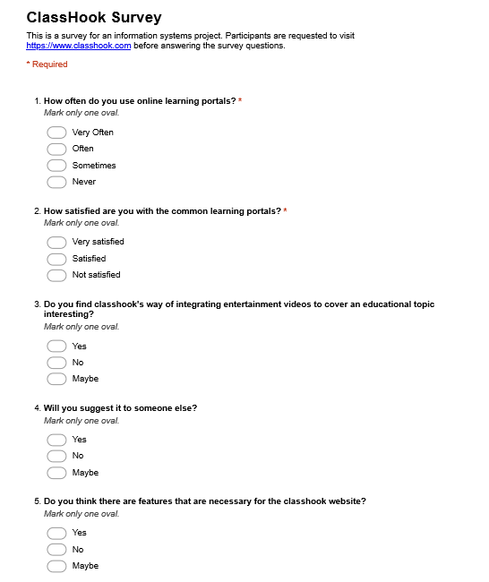

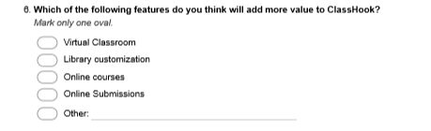

**RESPONSES**

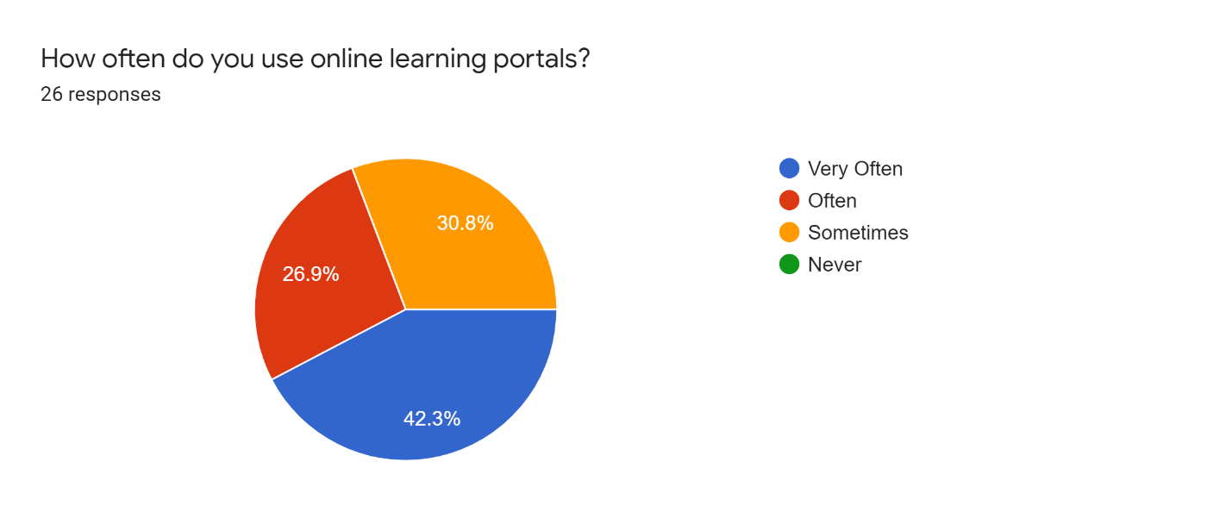

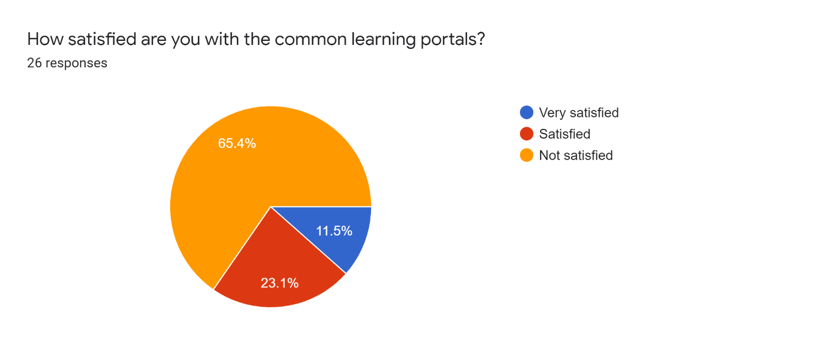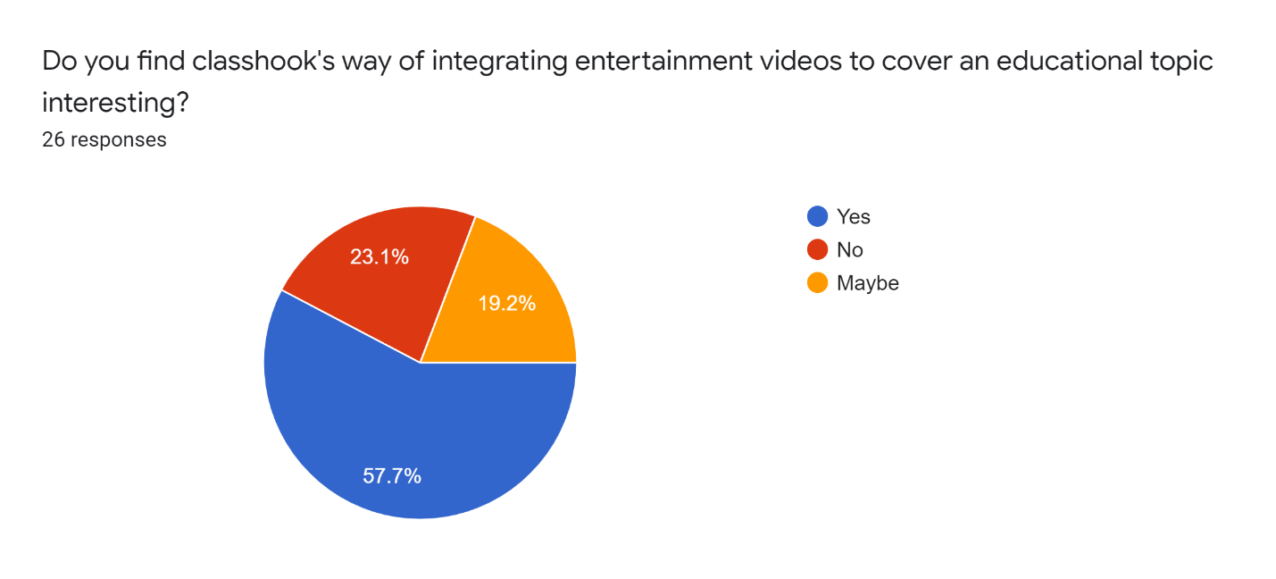

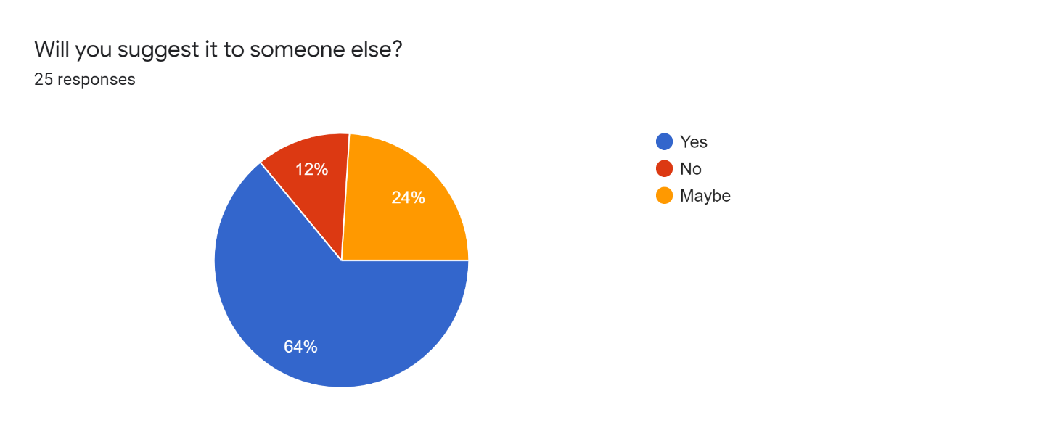

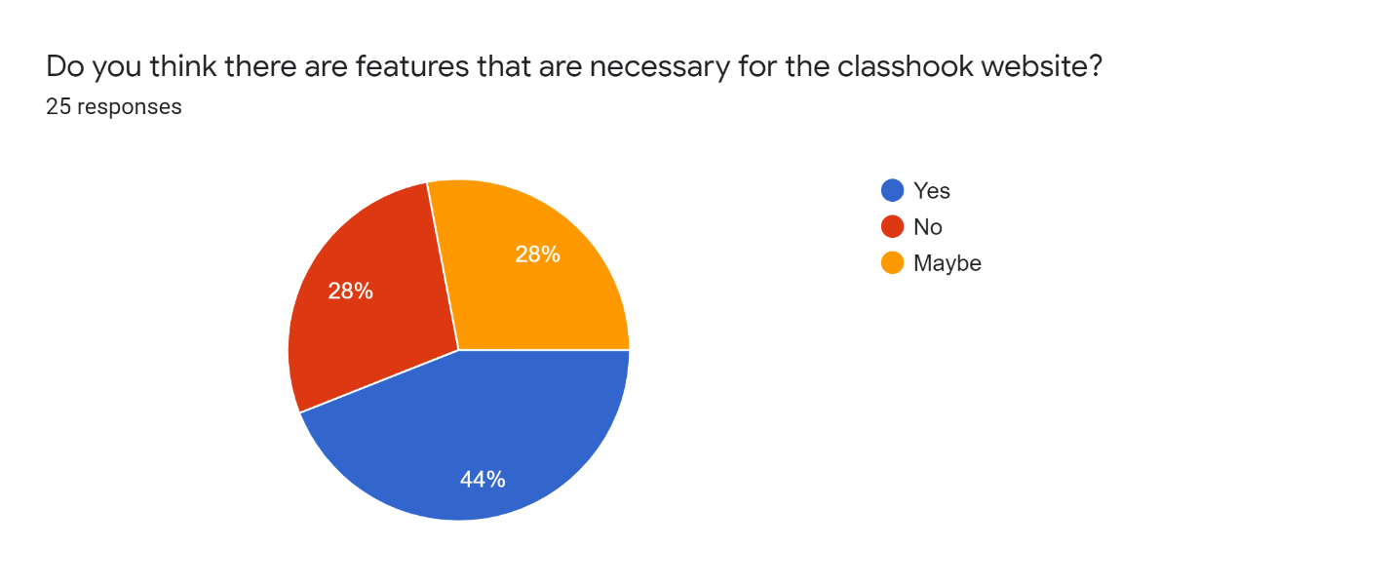

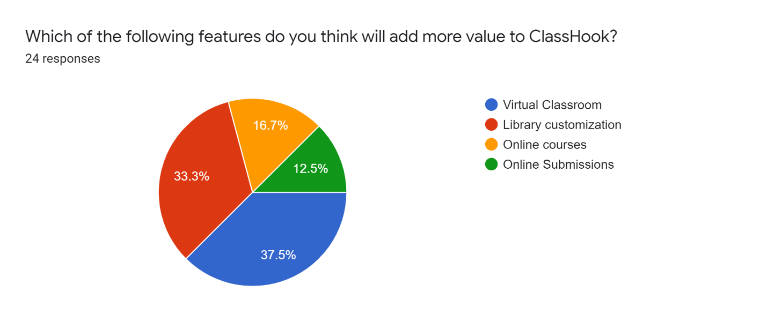

# Use Cases

|  |  |  |  |  |  |  |
| --- | --- | --- | --- | --- | --- | --- |
| **Use Case Name: Create Virtual Classroom** | | | **ID: 2.1** | | **Priority: High** | |
| **Brief Description:** This use case describes how a user can host a virtual classroom and perform teaching related activities. | | | | | | |
| **Actor:** ClassHook User (Instructor) | | | | | | |
| **Trigger:** User wants to create a virtual classroom.  **Type 🞎 ✓ External 🞎 Temporal** | | | | | | |
| **Preconditions:** 1. User has a registered ClassHook Account.  2. User has an active premium subscription. | | | | | | |
| **Normal Course:**   1. User selects the option to create a classroom from the dashboard. 2. Customization Options are displayed. 3. User enters the title, description, timings, size of the classroom, content type from the customization option for the virtual classroom to be created. 4. System stores details for the virtual classroom to be created. 5. User adds students to the newly created classroom by entering their Email ID 6. System stores the Email ID for students to be added to the classroom. 7. System sends invite links to the specified student Email ID. 8. Add student to the classroom when student opens and accepts the invite link. | | | | **Information for Steps**  ← Initiation  ← Classroom Details  → Entered Classroom Details  ← Student Email ID  → Entered Student Email ID  → Invite Link  → Student added | | |
| **Alternative Course(s):**  1.1: Entered Student Email ID is invalid (Occurs at Step.5)  1. The system displays message “Student Email Id is invalid”. → Display Error  2. The system asks the user if they want to add another student or to exit ← Request User Selection  3a. The user asks to add another student → Store User Selection  4a. The system starts Normal Course again  3b. The user asks to exit → Cancellation  4b. The system terminates the use case **→** Store User Selection and Exit | | | | | | |
| **Postconditions:** 1. Virtual classroom is created  2. Students have been added to the newly created classroom | | | | | | |
| **Exceptions:** 1. User’s premium subscription is no longer active. | | | | | | |
| **Summary: Inputs Source Outputs Destination** | | | | | | |
| Classroom Details  Student Email ID  Request User Selection | User  User  User | Entered Classroom Details  Entered Student Email ID  Invite Link  Student added  Display Error  Store User Selection  Cancellation  Store User Selection and Exit | | | | Classroom Datastore  Student Datastore  Student Datastore  Classroom Datastore  User  User  User  User |

|  |  |  |  |  |  |  |
| --- | --- | --- | --- | --- | --- | --- |
| **Use Case Name: Enroll for a Virtual Classroom** | | | **ID: 3.1** | | **Priority: High** | |
| **Brief Description:** This use case describes how a user can enroll and join a virtual classroom | | | | | | |
| **Actor:** ClassHook User (Student) | | | | | | |
| **Trigger:** User wants to join a virtual classroom.  **Type 🞎 ✓ External 🞎 Temporal** | | | | | | |
| **Preconditions:** 1. User has a registered ClassHook Account.  2. User has an active premium subscription.  3. User has received an invite link to join the classroom via an Email | | | | | | |
| **Normal Course:**   1. User opens the invite link received via Email. 2. System adds user to the related virtual classroom. | | | | **Information for Steps**  ← Invitation Link  → Student added | | |
| **Alternative Course(s):**  1.1: User has not received an invite link to join the virtual classroom  (Occurs at Step.1)  1. User selects the option to join a classroom from the dashboard. → Initiation from Dashboard  2. Selection Options are displayed. ← Request user selection  3. User enters the title, and name of the instructor who hosts the virtual  classroom to be joined. ← Classroom Details  4. System stores details for the virtual classroom to be enrolled. → Entered classroom details  5. System notifies the instructor about the enrollment request. → Enrollment Request  6a. i) The instructor accepts the enrollment request. ← Instructor Accept Selection  ii) System stores the accept selection and adds the users to the related  virtual classroom. → Student added  6b. i) The instructor rejects the enrollment request. ← Instructor Reject Selection  ii) System displays “Enrollment failed contact instructor”. → Enrollment failed message displayed  7. The system terminates the use case → Exit | | | | | | |
| **Postconditions:** 1. A student user joins the desired virtual classroom | | | | | | |
| **Exceptions:** 1. User’s premium subscription is no longer active.  2. Received invite link is broken/invalid | | | | | | |
| **Summary: Inputs Source Outputs Destination** | | | | | | |
| Invitational Link  Request user selection  Classroom Details  Instructor Accept Selection  Instructor Reject Selection | User  User  User  Instructor  Instructor | Student added  Initiation from Dashboard  Entered Classroom Details  Enrollment Request  Student Added  Enrollment failed Message Exit | | | | Student Datastore  Classroom Datastore  Classroom Datastore  Instructor  Student Datastore  User  User |

|  |  |  |  |  |  |  |
| --- | --- | --- | --- | --- | --- | --- |
| **Use Case Name: Submit Clip** | | | **ID: 2.7** | | **Priority: Medium** | |
| **Brief Description:** The user can submit clips in to the system’s database. | | | | | | |
| **Actor:** ClassHook User (Teacher) | | | | | | |
| **Trigger:** User selects clips for submission  **Type 🞎 ✓ External 🞎 Temporal** | | | | | | |
| **Preconditions:**   1. User is a registered teacher on ClassHook. 2. User has a premium subscription. | | | | | | |
| **Normal course:**   1. The user fills out mandatory blanks in the form such as URL, start time and end time of video, Title and Subject description. 2. The user submits the form. 3. The form is queued for submission. 4. System stores the submitted form. 5. passes it to the review component. 6. User receives a confirmation mail displaying clip submitted. | | | | **Information for Steps**  → Entered Clip Details  → Submits Form  ← Waiting for submission  → Gets submitted  → Review  ← Confirmation mail | | |
| **Alternative Course(s):**   1. The user does not fill all the mandatory blanks in to the form. ← Display error 2. The user tried to enter more than one URL. ←Asks to enter URL again | | | | | | |
| **Postconditions:**   1. The system gets notification of new content. 2. The user receives an email about the recent activity. 3. The clip gets submitted in to the ClassHook database. | | | | | | |
| **Exceptions:**   1. The user entered invalid URL. 2. The user posted video that has no educational content. 3. Copyright issues. 4. Profanity strikes are too high in to the clip. | | | | | | |
| **Summary: Inputs Source Outputs Destination** | | | | | | |
| Enter clip details  Submits the form  Review | User  User  User | Queued for submission  Confirmation Mail  Display Error  Ask to enter URL  Submit clip in to database | | | | Data store  User  User  User  Clip Datastore |

|  |  |  |  |  |  |  |
| --- | --- | --- | --- | --- | --- | --- |
| **Use Case Name: Review Clip** | | | **ID: 2.8** | | **Priority: Medium** | |
| **Brief Description:** The user can review clips and upload it to the database. | | | | | | |
| **Actor:** ClassHook User (Teacher) | | | | | | |
| **Trigger:** User selects clip for review from review status.  **Type 🞎 ✓ External 🞎 Temporal** | | | | | | |
| **Preconditions:**   * + - 1. 1. User is a registered teacher on ClassHook.       2. 2. User has a premium subscription. | | | | | | |
| **Normal course:**  1. The user selects clip to review from review status.  2 The user checks out the Profanity level, Educational content of the clip,  3 . Relevance of the clip, Subject description.   1. The user fills out the review report form. 2. The user submits review report form in to the system. 3. System sends confirmation mail. | | | | **Information for Steps**  → Selects clip from review status  → Checks all the fields  → Fills out the report form  → Gets submitted  ← Confirmation mail | | |
| **Alternative Course(s):**   1. The user does not fill all the mandatory blanks in to the form. ← Display error 2. The review report is not precise. ← Send mail | | | | | | |
| **Postconditions:**   1. The system gets notification of review report. 2. The user receives an email about the recent activity. 3. The clip gets submitted in to the ClassHook database. | | | | | | |
| **Exceptions:**   1. The system has already posted the video in to the database.   2 Copyright issues. | | | | | | |
| **Summary: Inputs Source Outputs Destination** | | | | | | |
| Selects clip  Checks all the fields  Fills out the form  Submit Review Report | User  User  User | Confirmation Mail  Display Error  Send mail for Unsuccessful clip submission | | | | User  User  User |

Data Flow Diagrams (DFD)

**Context Diagram**

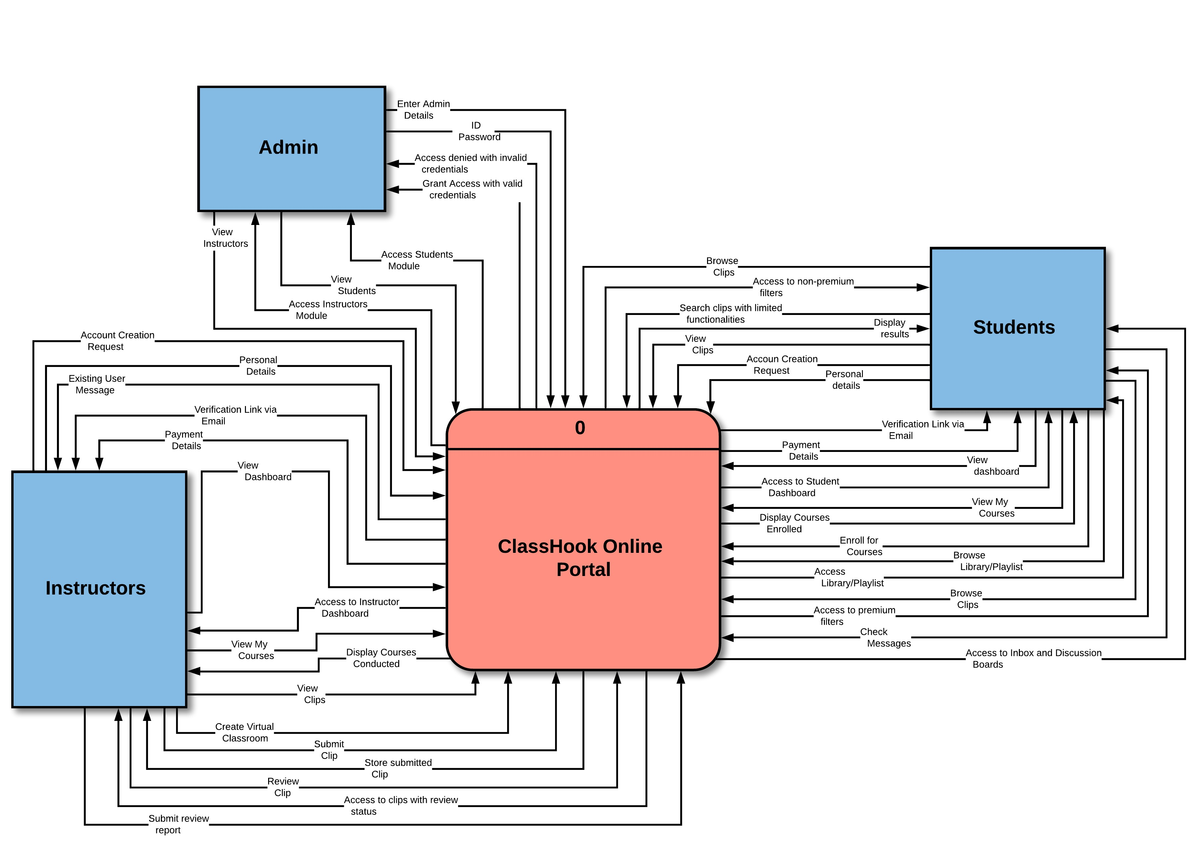

**Level 0**

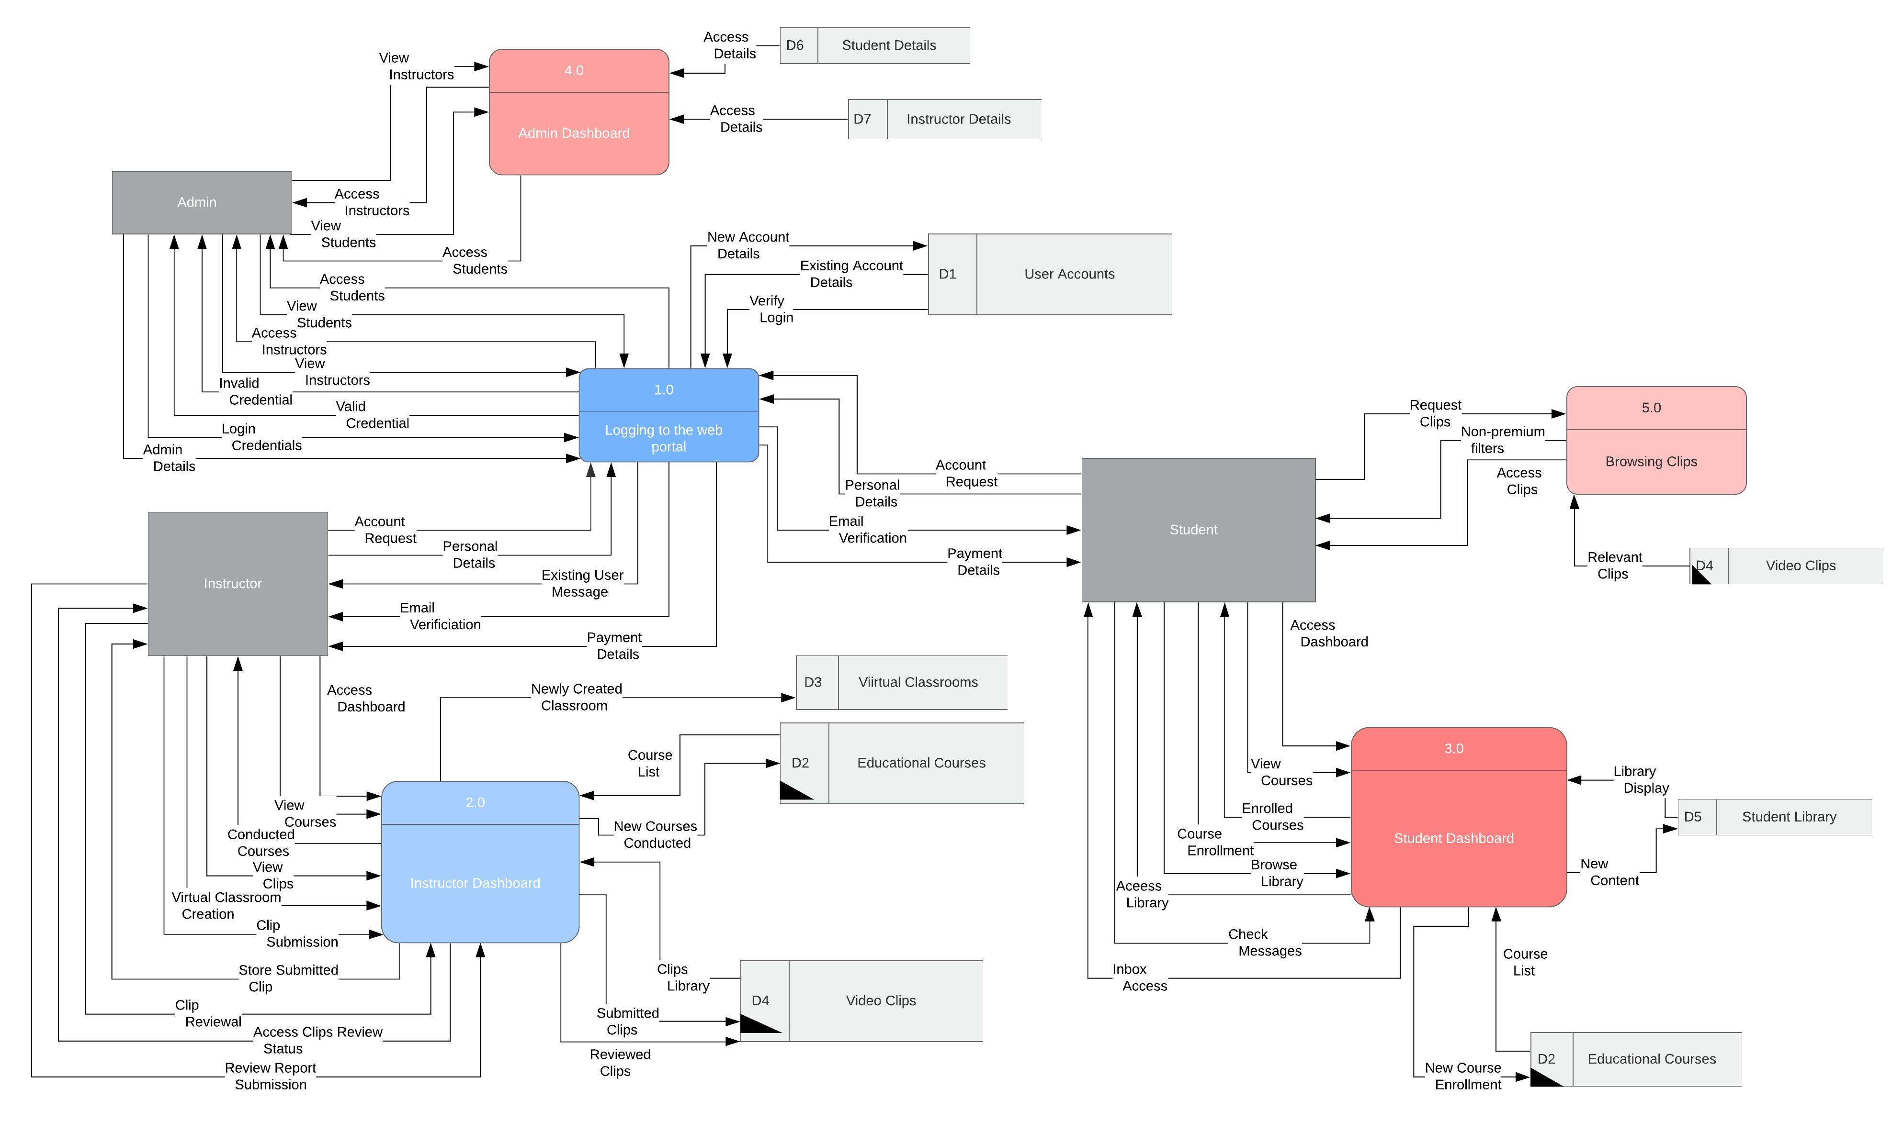

**Level 1 (2.1)**

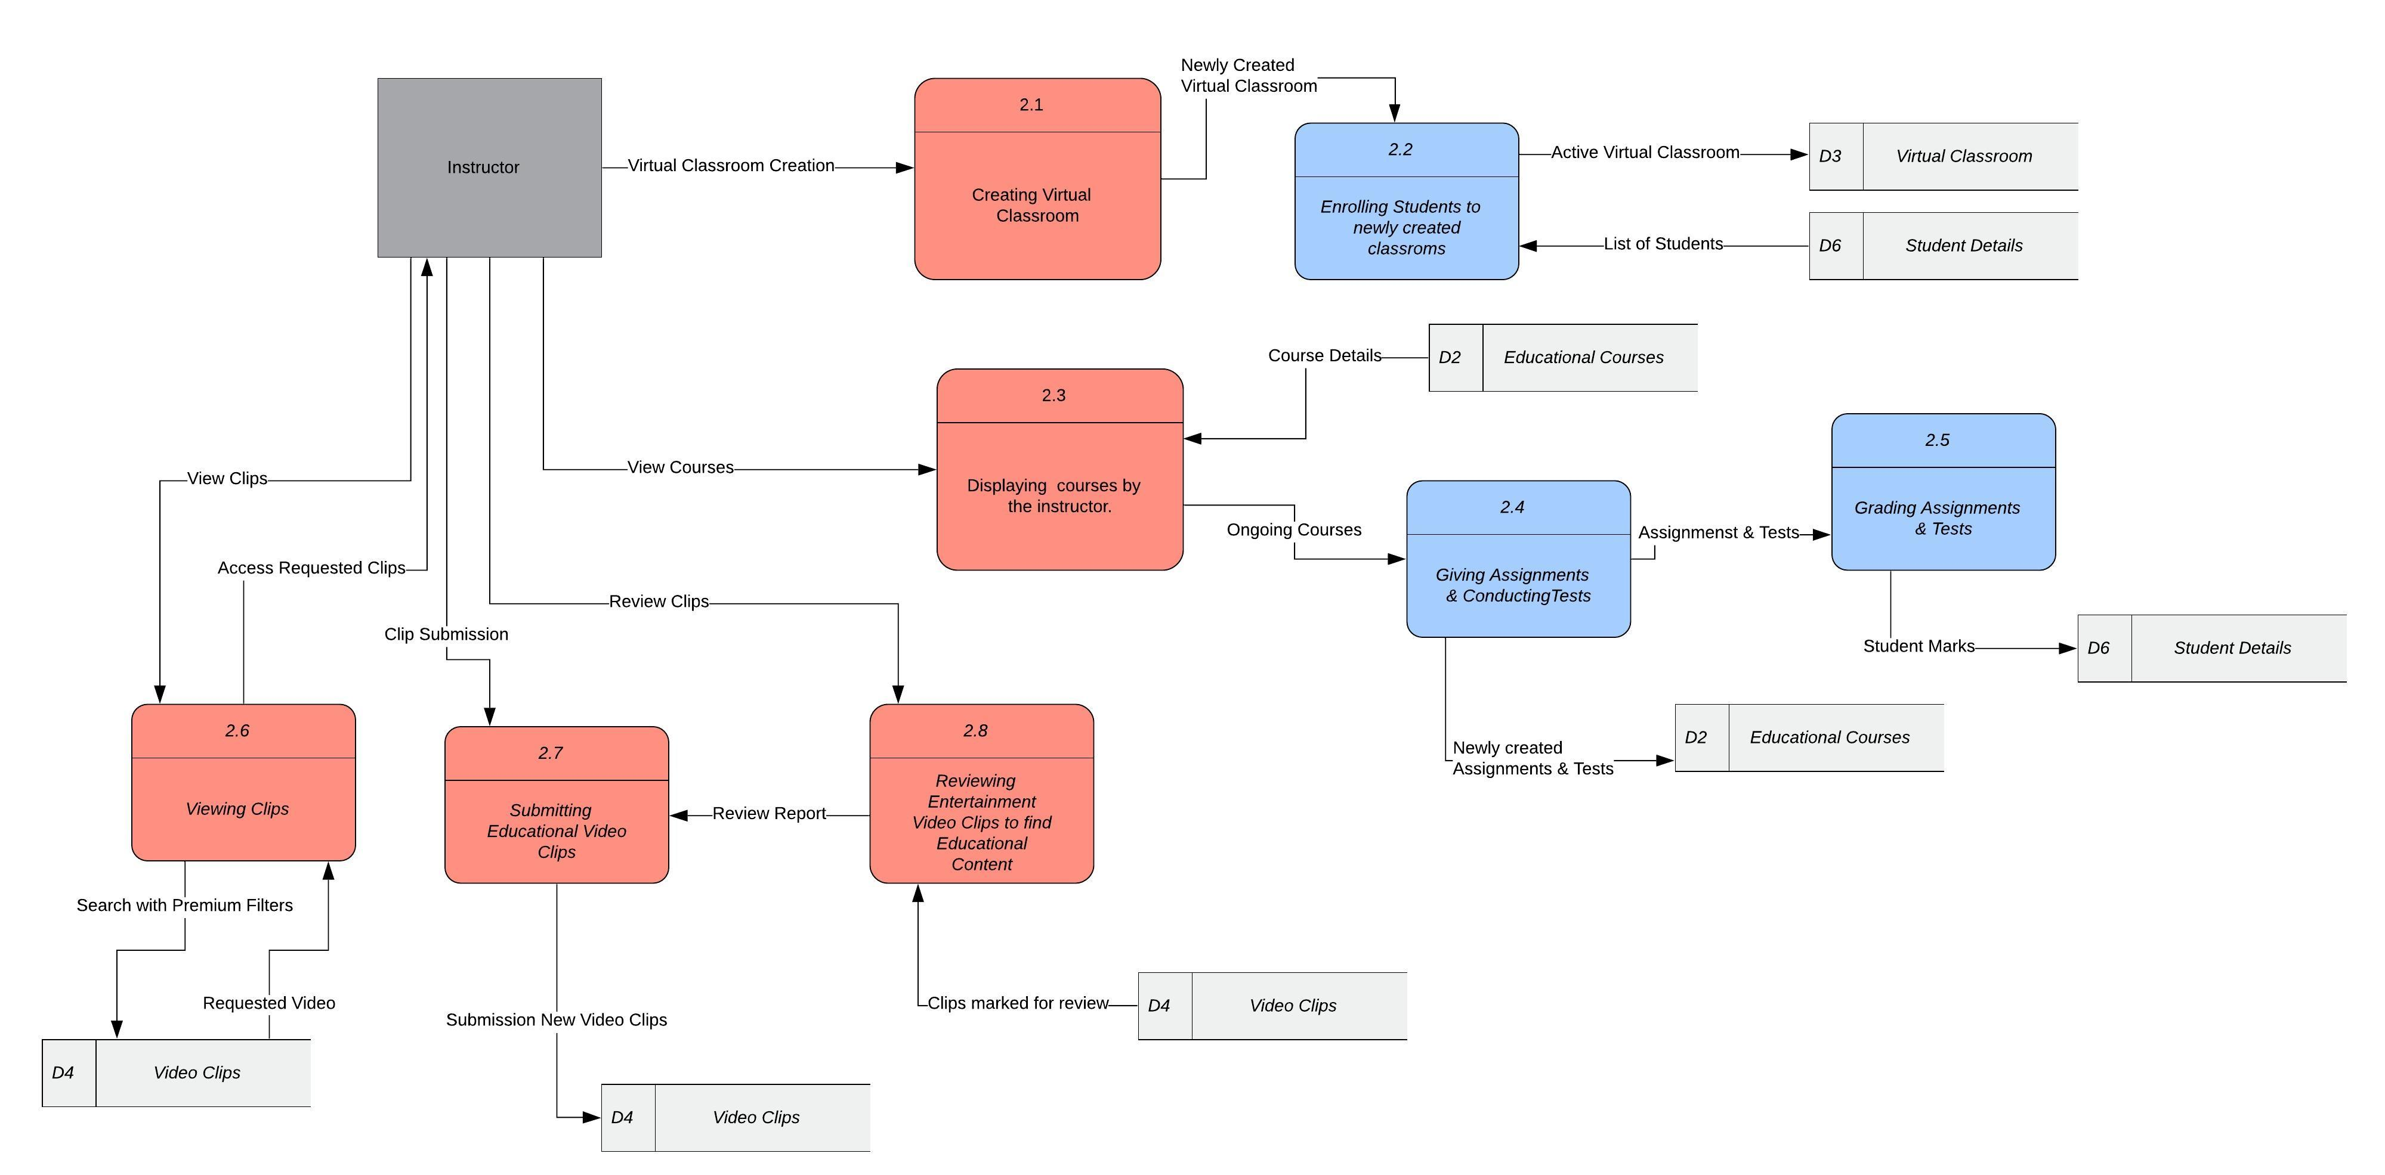

**Level 1 (3.1)**

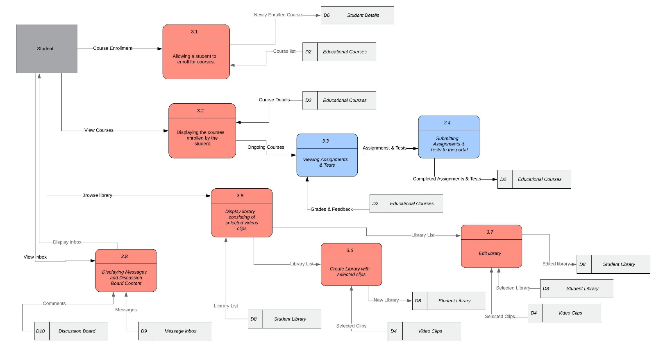

**Level 2 (2.1.1)**

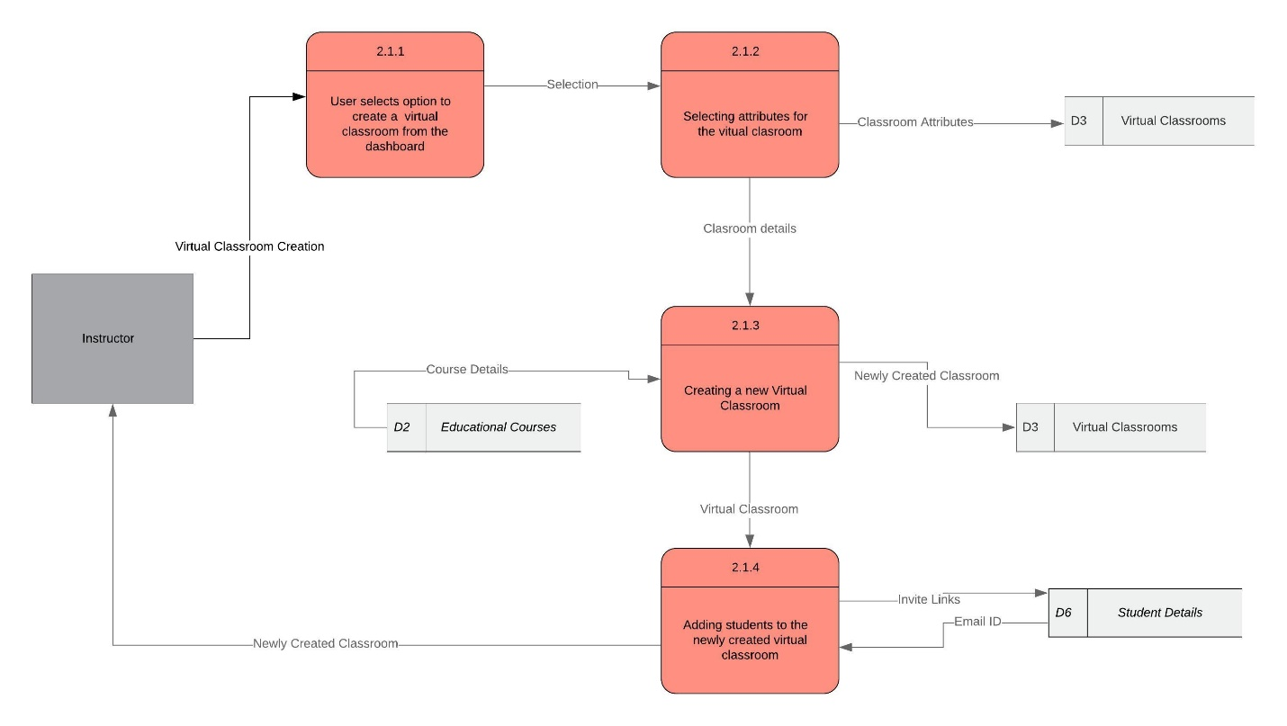

**Level 2 (3.1.1)**

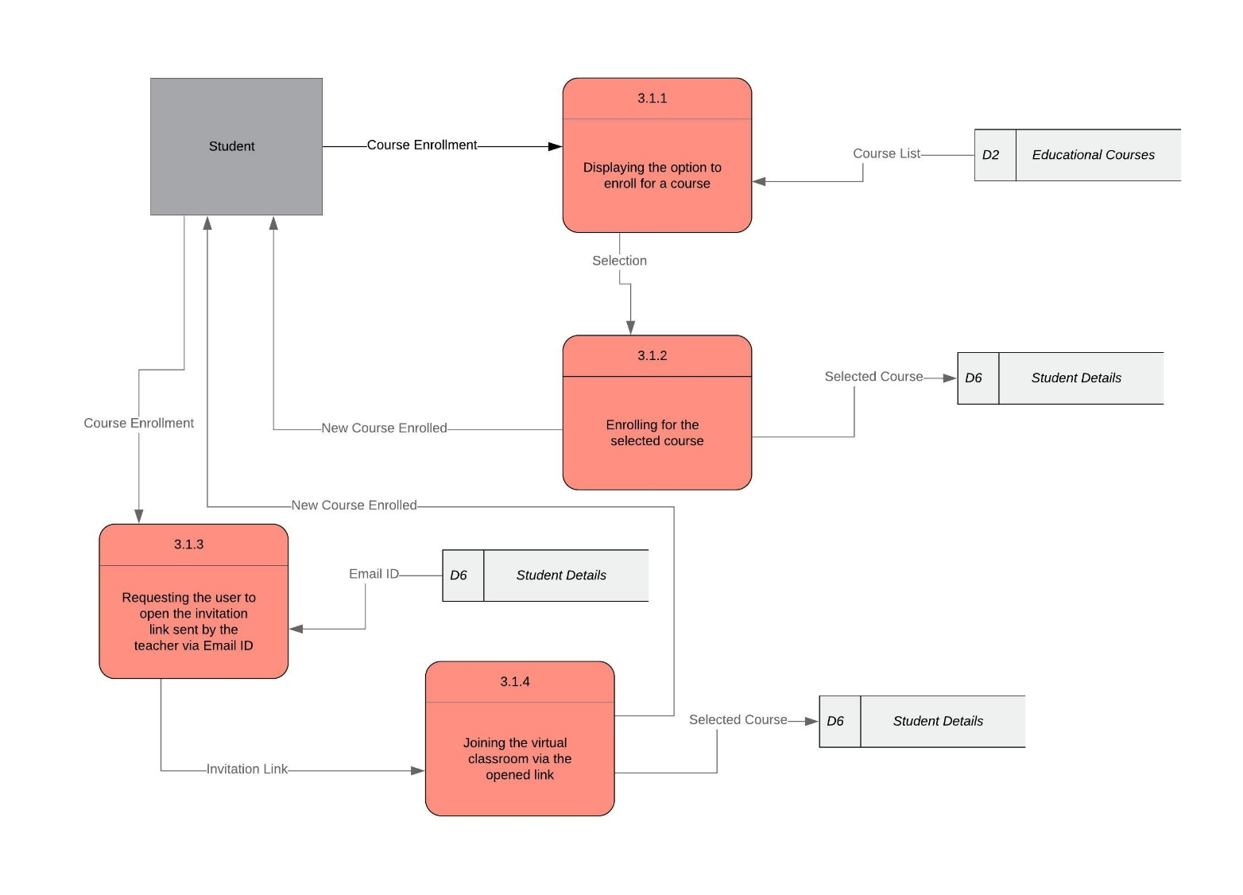

# Entity Relationship Diagram

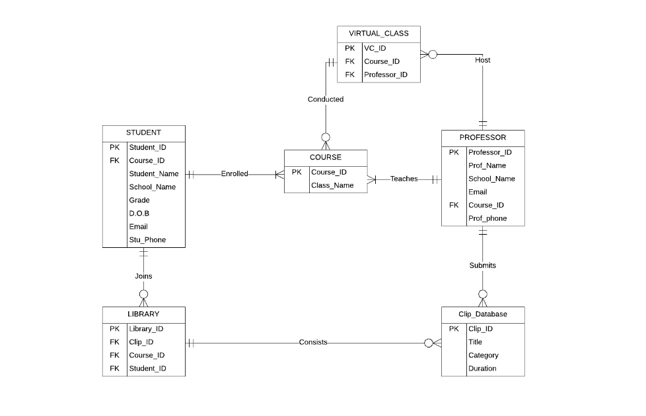

**Alternative Matrix**

|  |  |  |  |  |  |  |  |  |  |  |
| --- | --- | --- | --- | --- | --- | --- | --- | --- | --- | --- |
| Evaluation Criteria | Relative  Importance  (Weight) | Alt1:  In house | Score  (1-5) | Wtd Score | Alt2:  Outsource | Score  (1-5) | Wtd  Score | Alt3:  Buying third party packages. | Score  (1-5) | Wtd  Score |
| **Technical Issues**   1. Familiarity   With the  System   1. Compatibility of the system. 2. Time Frame | 20  15  25 | Developed on an existing system. User friendly interface.  Inhouse system developed will be compatible with the existing system.  The time frame of the system is critical as the system needs to be deployed in 3 months. | 4  4  3 | 80  60  75 | Outsourcing of the to-be system result into less control over the developed system.  To-be system would have less possibility of failure and will be able to serve more users if the functionalities are clearly stated.  Most efficient if the vendor is reliable | 3  5  4 | 60  75  100 | The staff need to be trained for the purchased packages.    High possibility of failure since the system may not be compatible with the existing system.  Since the package is already installed the only time consumed will be to train the staff. | 4  2  5 | 80  30  125 |
| **Economic Issues**   1. Cost | 20 | Expensive | 3 | 60 | Depending upon the vendor- might be expensive or not. | 3 | 60 | Less Expensive | 4 | 80 |
| **Organizational Issues**   1. Customizable 2. Other educational websites. | 10  10 | Somewhat  Similar educational material available from different websites | 3  4 | 30  40 | No  Similar educational material available from different websites | 1  3 | 10  30 | Yes  The purchased packages contain the manuals and instruction hence the training will be easier | 4  1 | 40  10 |
|  |  |  |  |  |  |  |  |  |  |  |
| **Total** | 100 |  |  | 345 |  |  | 335 |  |  | 365 |

**Revised Nonfunctional Requirements:**

1. Operational:

* The system should run on any technological device (Apple and Android mobile devices, tablet, laptop, desktop) used by employees, students, and teachers
* The system should be compatible with any web browser (Google Chrome, Internet Explorer, Microsoft Edge, Firefox, Safari, etc.)
* The video database will be constructed to facilitate searches by subject topic
* In the event of a failure during a virtual classroom or video download, the customer will be able to restart the download
* The system shall conserve battery life

1. Performance:

* The system should support up to 1,000 teachers and 30,000 students
* Download speeds for videos will be monitored and maintained at acceptable levels
* The user and system interaction should not exceed 1 second
* The system should be available to users for 365 day a year, 7 days a week, 24 hours a day
* The system must be scalable enough to support multiple users at a time

1. Security:

* Only teachers may host a virtual classroom for student collaborations and discussions
* Virtual classrooms are only available for subscribed teachers and are restricted to free users
* Only registered students may join a virtual classroom
* Only administrators have the authority to make website changes to ClassHook
* The system includes the necessary safeguards against viruses
* Personal information will be secured
* Payment information will be encrypted and secured
* Students and teachers can access their accounts with user and password

1. Cultural and Political:

* User’s personal information is protected in compliance with the United States Privacy Act of 1974
* The system should be able to distinguish between US currency and foreign currencies
* The system will operate in multiple languages (English, Spanish, Chinese, Korean, French, Italian)
* The system shall not display religious symbols, words associated with mainstream religions, or profanity
* No special customization requirements are anticipated
* No special legal requirements are anticipated

**System Specifications**

**Interface design**

**Web page/main menu/main page layout**

**System's Interface Structure Diagram or Dialogue**

**Diagram**

**Site Map**

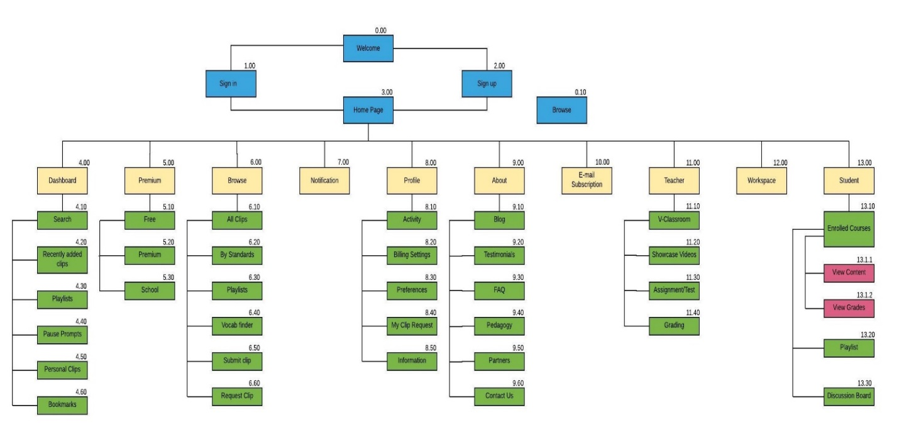

**Interface Standards**

**Interface Metaphor:** ClassHook Virtual Classrooms

**Interface Objects:**

* System Users: ClassHook employees, Students, and Teachers
* TV/Movie Clip list: List of TV/Movie Clips that match a specific criteria
* Title: Title of TV/Movie Clip
* Courses: List of all the courses taught by instructors
* Subject: Current subjects include Math, Science, Social Studies, English, Art, Music
* Favorite List: Somewhere for students and teachers to save their TV/Movie clips of interest
* Discussion Boards: A user can participate in discussions, forums and express their opinions
* Blackboard: An area for students and teachers to collaborate

**Interface Actions:**

* Create/host virtual classroom: Teachers can create and host virtual classrooms for students to join
* Join virtual classroom: Registered students may join virtual classrooms hosted by a teacher
* Search for Movie/TV clips: Display a list of movie and tv clips that match the specified criteria
* Browse courses: Display all the active ongoing courses to which the user can enroll
* Download: Students will be permitted to download any materials required for class
* Interface Icons: ClassHook logo will be displayed on all screens

**File/data specification**

***STUDENT***

|  |  |  |
| --- | --- | --- |
| **Student** | **Type** | **Field** |
| Student_ID | VARCHAR | 10 |
| Student_Name | VARCHAR | 50 |
| School_Name | VARCHAR | 50 |
| Grade | VARCHAR | 5 |
| Email | VARCHAR | 50 |
| Course_ID | VARCHAR | 10 |
| D.O.B | DATETIME | 50 |
| Stu_Phone | NUM | 10 |

***PROFESSOR***

|  |  |  |
| --- | --- | --- |
| **Professor** | **Type** | **Field** |
| Professor_ID | VARCHAR | 10 |
| Professor_Name | VARCHAR | 50 |
| School_Name | VARCHAR | 50 |
| Email | VARCHAR | 50 |
| Course_ID | VARCHAR | 10 |
| Prof_Phone | Num | 10 |

***COURSE***

|  |  |  |
| --- | --- | --- |
| **Course** | **Type** | **Field** |
| Course_Id | VARCHAR | 10 |
| Course_Name | VARCHAR | 50 |

***CLIP***

|  |  |  |
| --- | --- | --- |
| **Clip** | **Type** | **Field** |
| Clip_ID | VARCHAR | 10 |
| Title | VARCHAR | 50 |
| Category | VARCHAR | 50 |
| Duration | TIME | 10 |

***VIRTUAL CLASS***

|  |  |  |
| --- | --- | --- |
| **Virtual Class** | **Type** | **Field** |
| VC_ID | VARCHAR | 10 |
| Course_ID | VARCHAR | 10 |
| Professor_ID | VARCHAR | 10 |

***LIBRARY***

|  |  |  |
| --- | --- | --- |
| **Library** | **Type** | **Field** |
| Lib_ID | VARCHAR | 10 |
| Clip_ID | VARCHAR | 10 |
| Course_ID | VARCHAR | 10 |
| Student_ID | VARCHAR | 10 |

**CRUD Matrix**

|  |  |  |  |  |  |  |
| --- | --- | --- | --- | --- | --- | --- |
| Entity Process | User | User Profile | User library | User Account | Classhook Invoice | Product |
| Receive User Request | R | C U |  | U |  |  |
| Process Customer Request | CRU |  |  |  |  | R |
| Maintain User Account | U | U |  | U |  |  |
| Add / Remove Subjects |  |  | C U |  | C | U D |
| Sharing User Libraries | U |  | C |  |  | R |
| Create Virtual Classroom |  |  |  | U |  | C D |
| Enroll for Virtual Classroom | U |  |  | U | C |  |
| Create User Invoice |  |  |  |  | C |  |
| Validate Classhooks Invoice |  |  |  |  | R |  |
| Terminate User Account | U |  |  | D |  |  |
| Uploading a video clip | R |  |  |  |  | C |
| Reviewing a video clip |  |  |  |  |  | R |
| Submitting an assignment | C |  |  | U |  | R |
| Grading an assignment |  |  |  | U |  | R |
| Upgrading to a premium account | C |  |  | U |  | C R U |
| Adding/Updating personal details |  | C R U |  |  |  |  |
| Selecting a plan | C R |  | U |  | U |  |

## **Executive Summary**

Our group has collaborated with ClassHook on a project designed to deploy useful functionalities and subsequently increase the number of subscriptions. The project was introduced based on the following business needs:

* The current system has limited functionalities for students.
* There is a need for an online portal to conduct courses, host classrooms, and perform educational activities such as store class material, conduct tests and assignments, assign grades, post due dates and feedback, make announcements etc.
* Define new methods to increase and organize the media files in the current system.

Our group conducted an extensive feasibility study for the technological, economical and organizational aspects. We concluded that the proposed ClassHook system is feasible with a very low risk factor. In addition, we evaluated the increased educator satisfaction, development costs, and operational costs. According to our analysis, the project should provide a 2,628% return on investment.

The proposed system for ClassHook was analyzed for potential risks which could impact the system. Our analysis suggests that the project included one moderate risk dependent on if the information system can support an excessive amount of users at one time. To mitigate this risk, we have shared our thoughts with Alex Deeb, CEO of ClassHook, that when the system is implemented, to avoid the system from crashing, consistent maintenance will be required.

Functional and nonfunctional requirements were prepared to better understand what the system is required to do and satisfy the user’s needs.

## **Project Lessons Learned**

Matt Esposito – Despite not having any knowledge related to information systems prior to the project, it really helped me gain hands on experience regarding developing an information system. The project has really enhanced my quality of work capabilities as it involved extensive iterative development on all three deliverables. Furthermore, it was clear from deliverable one how important project management, team collaboration and timeboxing can be prior to deadlines and submissions.

Jibin Thomas –

Jaymeen Gandhi - Taking this course helped in managing the project , time management, how scope creep affects the project, how every milestone should be achieved, creating use cases and dfds. The project has thought me about the work condition of the corporate world.

Sweni Thakkar –

## **List of References**

Systems Analysis & Design - 6th Edition, Authors: Dennis, Wixom and Roth

ClassHook.com